  



|  |  |
| --- | --- |
| Minutes | |
| **SONIA Stakeholder Advisory Group** | |
| 10 October 2018 | |
| **Location:** | Bank of England |
| **Minute no.** | **Minute** |
| 1. | **Introductions and Terms of Reference**  The Chair thanked all for participating in the SONIA Stakeholders Advisory Group. He explained that the rationale for identifying which entities participated in the Group was set out in the Terms of Reference and reflected the current uses of SONIA. The membership of the Group would therefore change over time as the usage of SONIA evolves. The Chair noted that ICE Futures and Curve Global would alternate as attendees.  The Bank provided the broader context of the governance around the administration of SONIA. The SONIA Stakeholders Advisory Group’s role is to feed the views of external stakeholders into the both the Bank, to facilitate their administration of SONIA, and to the SONIA Oversight Committee, to facilitate their challenge on all aspects of the benchmark determination process and provides scrutiny of the administration of SONIA.  The Chair outlined the Terms of Reference1 for the Group, which were agreed by all. |
| 2. | **Review of the transition to reformed SONIA**  There were two main impacts to SONIA users of the reforms: the change in publication time from 6pm on T to 9am on T+1; and a change in methodology which lead to a spread between old and reformed SONIA of around 1.5 bps. The Chair asked for views on how the market felt the reforms to SONIA were implemented.  The Group felt that the transition to reformed SONIA was as smooth as it could have been, with no issues upon transition being encountered. The information provided to the market was clear, concise and helpful, especially on what was expected around the cutover.  The work on the transition to reformed SONIA is now being used as an example of best practice and is being followed by a number of Group members for other benchmark transitions.  The Chair congratulated the Bank on a well-managed transition. |
| 3. | **Review of market conditions**  The Bank presented a pack of publically available statistics on the SONIA rate over the six months since the reforms were implemented.2 The rate was consistently around 5 basis points below Bank Rate, and quickly stabilised at the new level when Bank Rate increased on 2 August 2018.  The MI also showed a small decline in volumes over the last four months. The Group discussed some of the drivers of increases and decreases in SONIA volumes. These included:   * cross currency swaps, where the relative price of sterling against the euro and dollar could make transacting in sterling and then swapping to another currency more (or less) advantageous leading to increases (or decreases) of SONIA volumes, and |

1 <https://www.bankofengland.co.uk/-/media/boe/files/markets/benchmarks/sonia-stakeholders-advisory-group-terms-of-reference>

2 The pack is appended to these minutes.

|  |  |
| --- | --- |
|  | * the relative price and availability of collateral will contribute to the decision on whether to undertake secured or unsecured lending, i.e. volumes in SONIA decrease where firms find better value trading in the secured market.   In addition, there are specific drivers of volumes at period-ends, where regulatory considerations mean that it could be more advantageous to undertake secured rather than unsecured activity.  Looking ahead, possible influences on future SONIA volumes included the implementation of the EU Money Market Fund (MMF) reforms and Brexit. It was noted that given the lack of clarity on final terms of Brexit the precise impact remained uncertain. At one end of the spectrum, there could be no impact; at the other, if barriers were put in place on transferring funds between entities, this could lead to a bifurcation of the sterling money markets.  It was discussed that despite SONIA volumes having declined recently, this had not resulted in volatility in the rate. Members agreed that stability of the SONIA rate itself was more important than stability in the volumes. This was reinforced when it was possible to understand the drivers for such changes in volume. To that end, Members thought it would be helpful to track the overall activity in the sterling money markets to see if the unsecured volumes had migrated to the secured market or had been swapped into other currencies. The Bank noted that from October 2018 it would publish quarterly updates on sterling unsecured and secured money market activity based on SMMD data. Notwithstanding that, the concentration in the market was important to monitor, especially if there were persistent declines in volumes. The Bank had previously published concentration comparisons between old and reformed SONIA, so Members thought continuing to publish these may be worthwhile.  Looking forward, the market was better prepared for the forthcoming year-end and no impact on the SONIA rate was anticipated. There was clear communication with their customers to establish the likely activity in advance of year end. Banks were unlikely to take unexpected deposits regardless of the rate – the economic gain for the trade would be outweighed by regulatory considerations.  Changes in monetary policy such as the future framework for controlling interest rates and the QE unwind were likely to have an impact on money market activity and therefore potentially an impact on the SONIA rate and volumes. It will be important to maintain and understand the link between Bank Rate and SONIA. If the monetary policy changes have an explainable impact on SONIA then that in itself would not be concerning. |
| 4. | **Evolving uses of SONIA**  The Chair observed that a lot of work was ongoing in this space. He distinguished the role of this Group compared to other bodies. While the role of the Working Group on Sterling Risk- Free Reference Rates was to catalyse a broad-based transition to using SONIA as the primary sterling interest rate benchmark in bond, loan and derivatives markets, the role of this Group was to consider how the uses of SONIA were evolving and provide views on the implication of this for the administration of SONIA.  The Group noted the recent issuances in SONIA referencing bonds and the increase in SONIA futures activity.  There was an initial discussion as whether additional guidance on managing possible conflicts of interest was needed for reporters submitting to a transaction based benchmark. |
| 5. | **Future discussion topics**  The Chair noted the next meeting of the Group would be in February 2019, when there would be greater clarity on the Brexit terms and the impact of those and the EU MMF reforms on SONIA could be assessed.  He also encouraged Members to propose issues for future discussions. |

### Attendees:

Chair Richard Moore (Independent member of SONIA Oversight Committee)

Goldman Sachs Nikhil Choraria

HSBC James Murphy

ICE Futures Chris Rhodes Insight Investment Robert Gall ISDA Jonathan Martin

LCH Philip Whitehurst

LGIM John Wherton

Lloyds Bank Graham Whitehair

Mizuho Rob Thurlow Société Generalé Romain Sinclair TP ICAP Philip Chilvers

Bank of England Rhys Phillips Will Parry Paul Burton

### Apologies:

Julia Black (Independent member of SONIA Oversight Committee)

**SONIA Stakeholder Advisory Group**

October 2018

# Published SONIA statistics

## Chart 1: SONIA volumes £bn

70

Go Live ‐ 23

April

60

50

40

30

20

10

0

## Chart 2: SONIA rates and percentiles

25th - 75th percentiles 10th - 90th percentiles SONIA

Percent

0.75

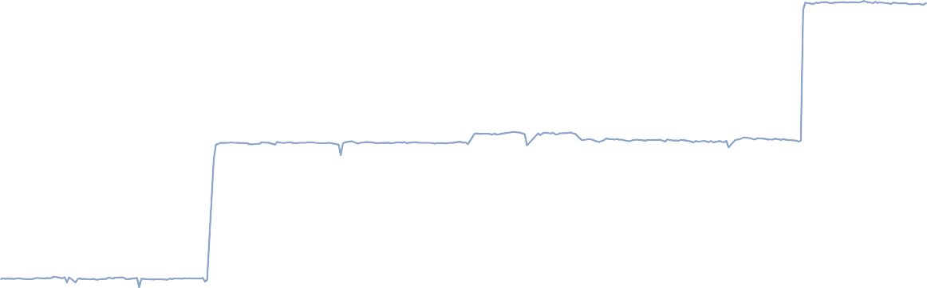

Go Live ‐ 23

April

0.65

0.55

0.45

0.35

0.25

0.15

0.05

*Volumes, rates and percentiles before 23 April 2018 are calculated using SMMD data. This can be found on the Banks website as the data presented in the ‘SONIA key features and policies document’ under the reformed methodology.*

# Usage of SONIA

## Chart 3: SONIA Futures

− monthly nominal volumes*

£bn £bn

## Chart 4: SONIA Futures

− Open Interest at month‐end

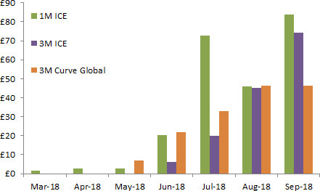 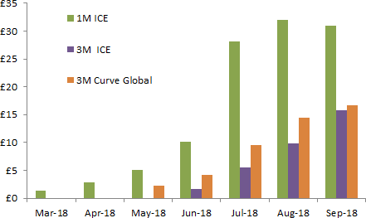

*Source: ICE Futures and Curve Global*

*\* Lots traded multiplied by nominal lot size*

*Source: ICE Futures and Curve Global*

## Table 1: SONIA Bond Issuances

|  |  |  |  |  |
| --- | --- | --- | --- | --- |
| **Date** | **Issuer** | **Amount** | **Maturity** | **Issue spread to SONIA**  **(bps)** |
| **29/6/18** | European Investment Bank | £1bn | 5y | 35 |
| **4/9/18** | Lloyds Bank | £750mn | 3y | 43 |
| **6/9/18** | RBC | £350mn | 1y | 25 |
| **11/9/18** | Santander UK | £1bn | 3y | 43 |
| **27/9/18** | World Bank | £1bn | 5y | 24 |
| **2/10/18** | Asian Development Bank | £600mn | 5y | 25 |